F Y B Tech SEM I 2021-22

Engineering Physics Lab Course

**Experiment No.: 3**

**Title: Determining Planck’s Constant**

**Name: Eshan Kalp Trivedi**

**Roll No: 16010221038**

**Branch: EXTC**

**Batch: D2**

**Aim:** Determination of Planck’s constant

**Apparatus:** 0-10 V power supply, one-way key, rheostat, digital milliammeter, digital voltmeter, 1K resistor, different LEDs of known wavelengths

**Diagram:**

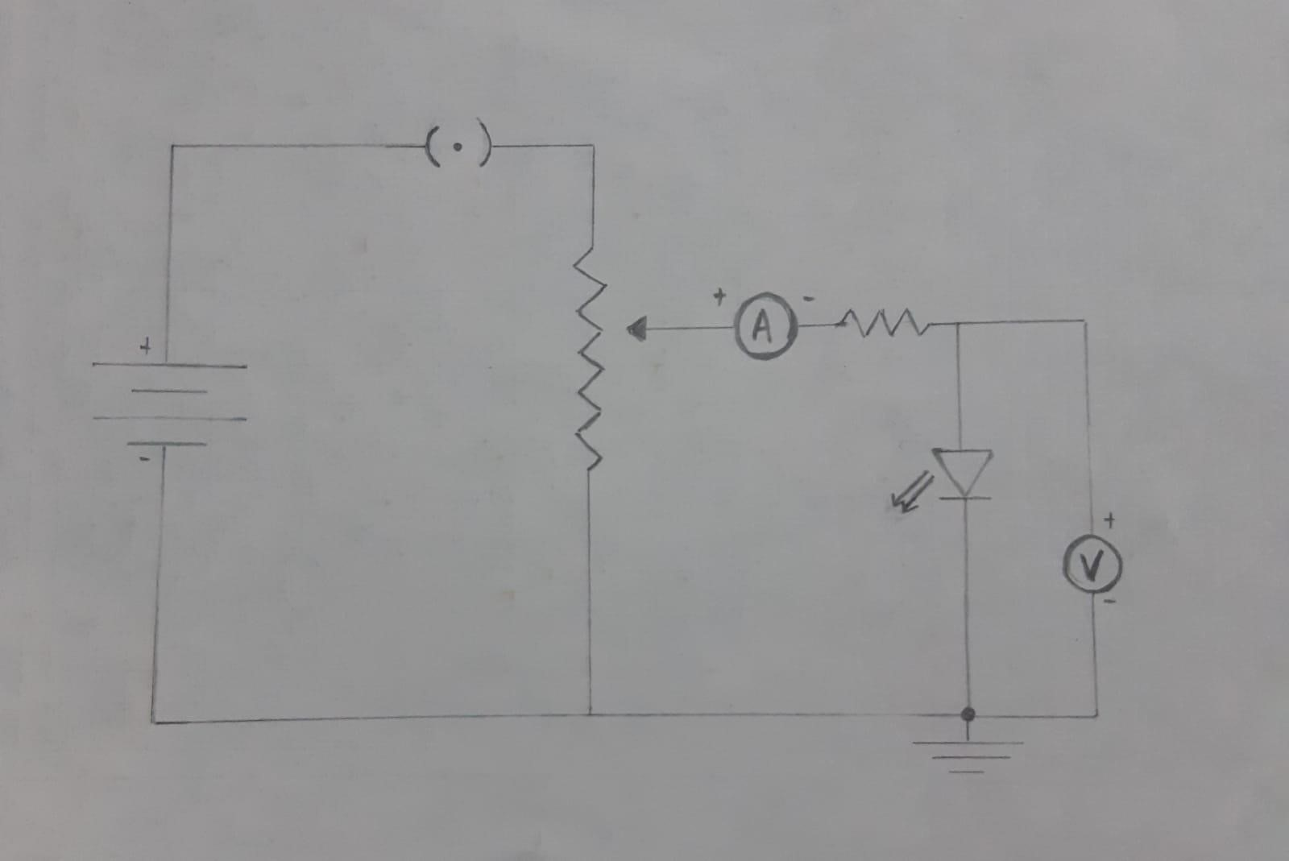

**Observation Table:**

|  |  |  |  |  |  |  |
| --- | --- | --- | --- | --- | --- | --- |
| LED: Red  Wavelength: **650 nm** | | LED: Yellow  Wavelength: **570 nm** | | | LED: Green  Wavelength: **510 nm** | |
| Voltage (V) | Current (mA) | Voltage (V) | Current (mA) | | Voltage (V) | Current (mA) |
| 1.9 | 0 | 2.170 | 0 | | 2.430 | 0 |
| Vth = 1.908 | 1.590 | Vth = 2.178 | 1.815 | | Vth = 2.434 | 2.029 |
| 2.250 | 1.875 | 2.300 | 1.916 | | 2.601 | 2.167 |
| 2.502 | 2.085 | 2.601 | 2.167 | | 2.804 | 2.336 |
| 2.754 | 2.295 | 2.804 | 2.336 | | 3.002 | 2.501 |
| 3.002 | 2.501 | 2.902 | 2.419 | | 3.100 | 2.584 |
| 3.200 | 2.666 | 3.002 | 2.501 | | 3.200 | 2.666 |
| 3.402 | 2.835 | 3.227 | 2.689 | | 3.402 | 2.835 |
| 3.600 | 3.000 | 3.704 | 3.086 | | 3.600 | 3.000 |
| 3.803 | 3.169 | 3.901 | 3.251 | | 3.803 | 3.169 |
| 4 | 3.334 | 4 | 3.334 | | 4 | 3.334 |
| Vth: Threshold voltage/knee voltage | | | |  | | |

|  |  |  |  |
| --- | --- | --- | --- |
| Sr. No. | Wavelength λ (nm) | 1/λ (nm-1) | Vth (volt) |
| 1. | 650 nm | 0.0015 | 1.908 |
| 2. | 570 nm | 0.0017 | 2.178 |
| 3. | 510 nm | 0.0019 | 2.434 |

**Screenshot**

**of an experimental set up:**

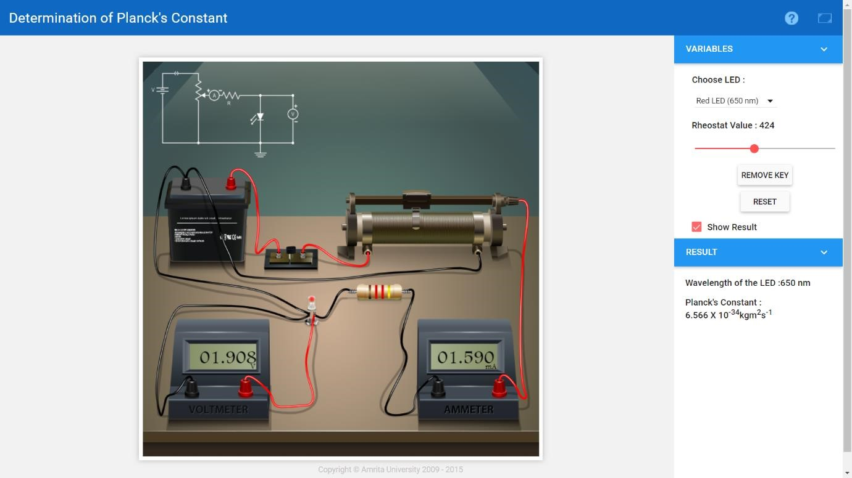

**Graphs:**

Graph 1: Voltage(x-axis) vs current(y-axis) for three different LEDs- Red, Yellow and Green

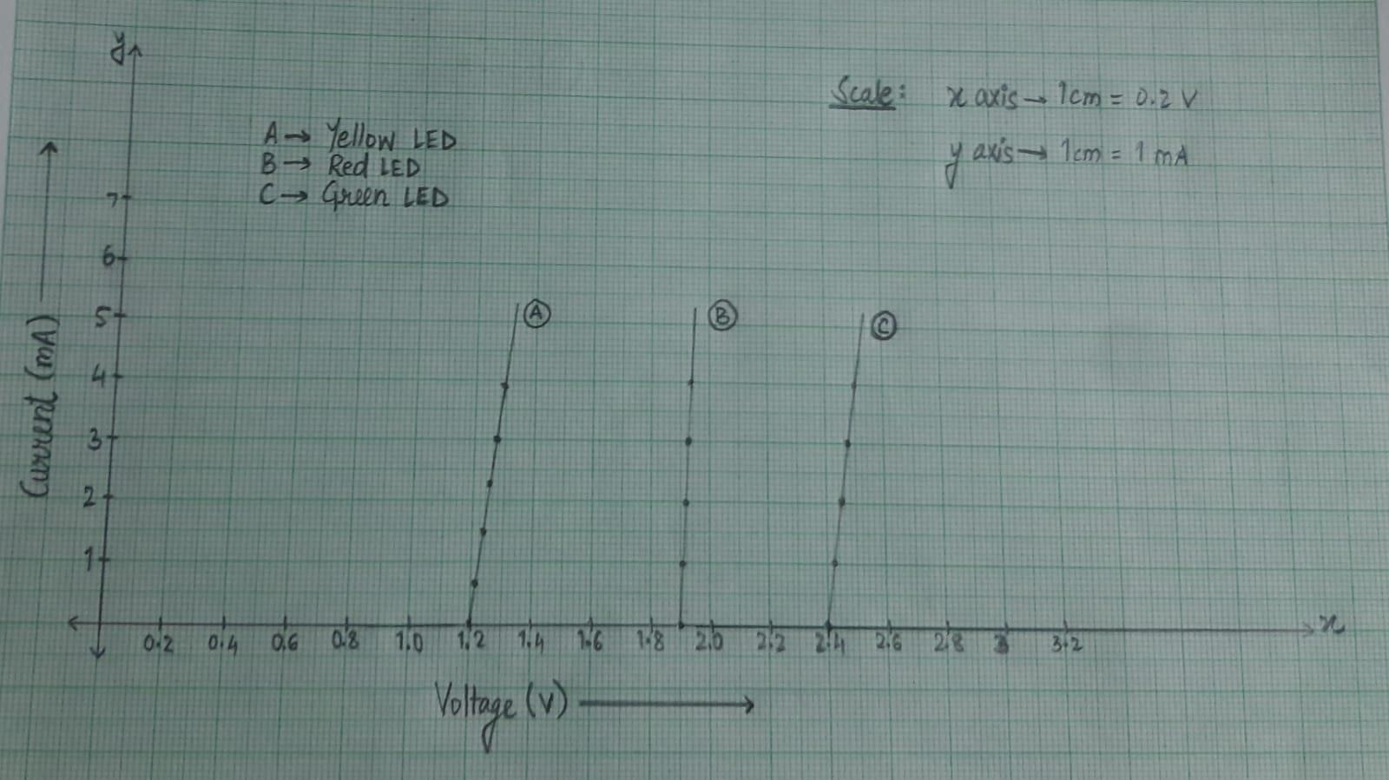

Graph 2: Threshold voltage vs reciprocal of wavelength

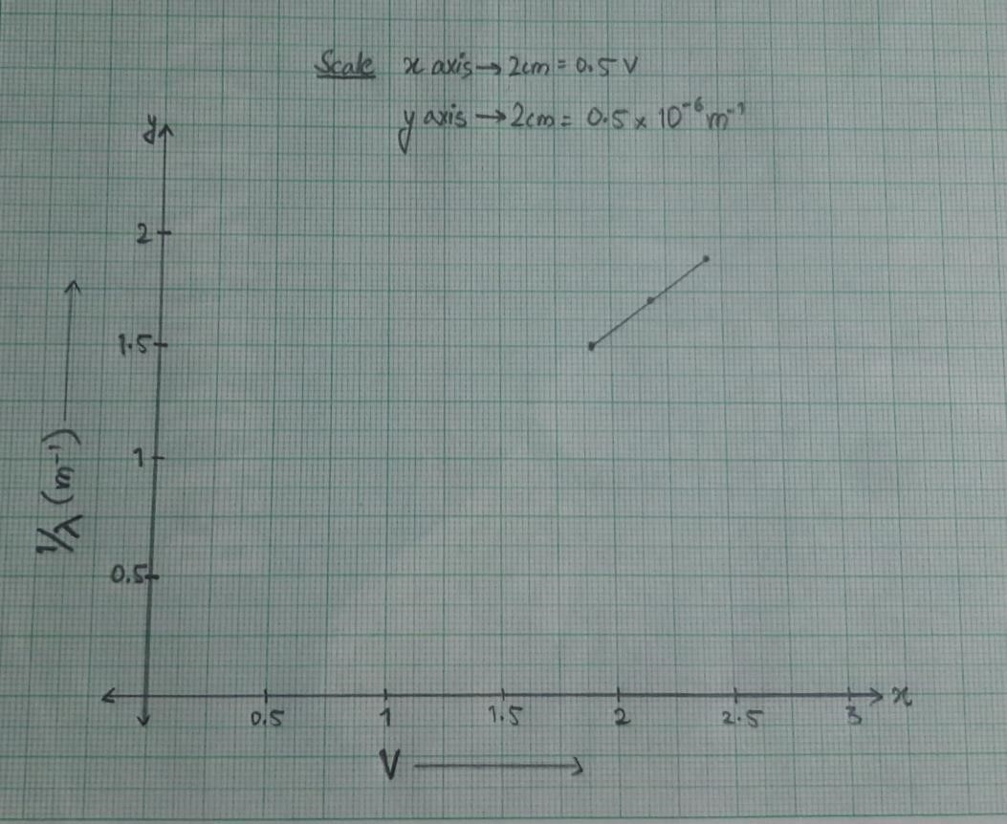

**C**

**alculation**

**s**

**:**

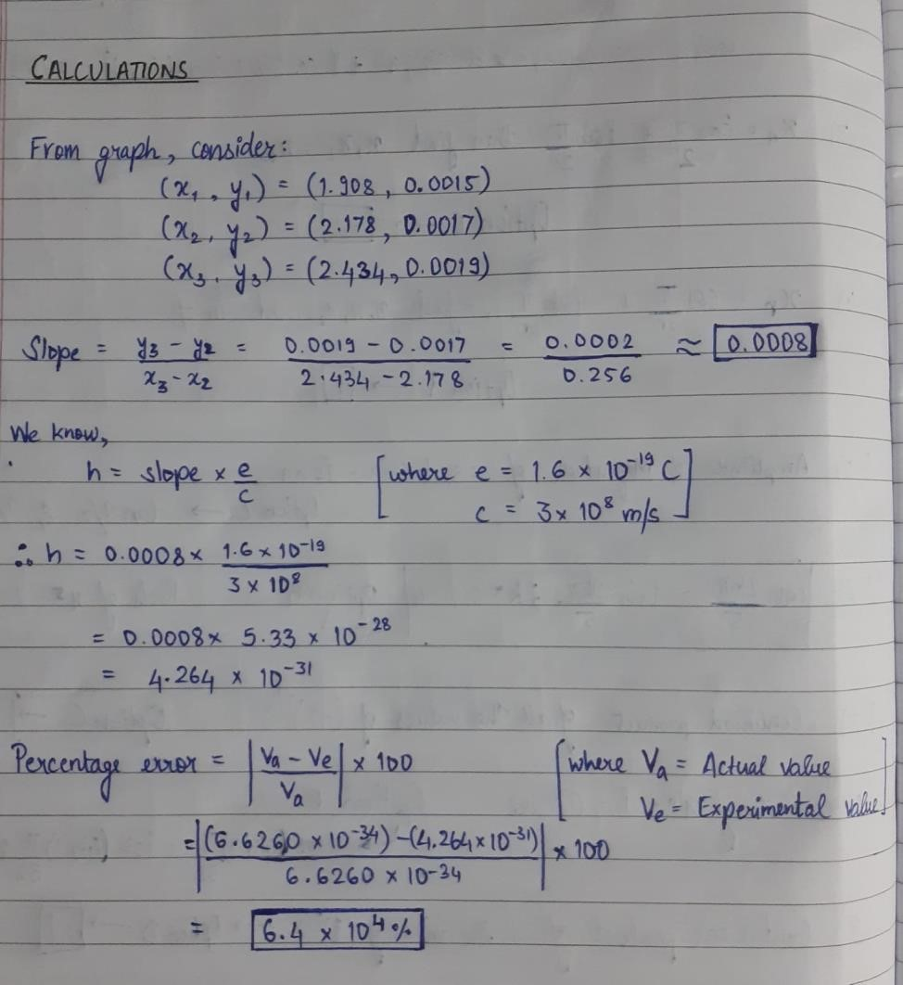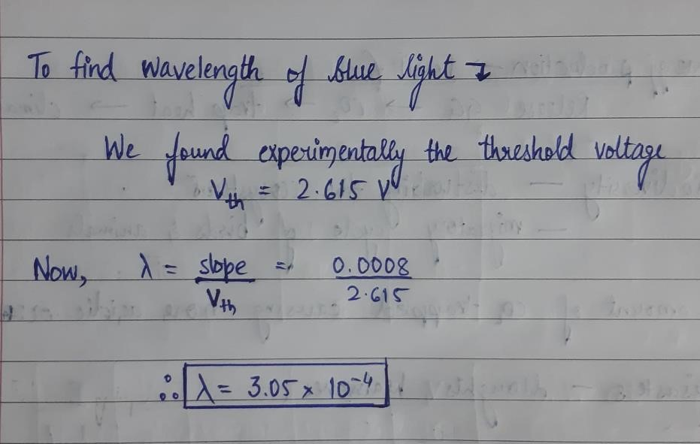

**Results and conclusion:**

From above calculations h = 4.264*10e-28 This value compares with the accepted value for the Plank’s constant of 6.6260*10e-34 with an error of 6.4*10e4%